Activity :- Microsoft Intune
Microsoft Intune is a cloud-based service that provides a unified endpoint management solution for an organization's devices, apps, and data. It helps IT administrators manage a wide range of devices, including corporate-owned and "Bring Your Own Device" (BYOD) devices, across different platforms such as Windows, macOS, iOS/iPadOS, and Android.
Key features and capabilities of Microsoft Intune include:
- Mobile Device Management (MDM): Intune allows for the enrollment, configuration, and management of mobile devices. It can enforce security policies, manage settings, and remotely wipe or lock a device if it is lost or stolen.
- Mobile Application Management (MAM): This feature protects organizational data within apps, even on personal devices that are not fully enrolled in Intune. It allows administrators to deploy, update, and remove applications, and set policies for data sharing and access.
- Conditional Access: Intune integrates with Microsoft Entra ID (formerly Azure Active Directory) to create policies that ensure only compliant devices and authorized users can access corporate resources.
- Integration with other Microsoft Services: Intune works with other Microsoft products, such as Microsoft 365, Microsoft Defender for Endpoint, and Windows Autopilot, to provide a comprehensive security and management solution.
The benefits of using Microsoft Intune include enhanced security, simplified device management for a diverse workforce, improved compliance with regulations, and support for remote and hybrid work environments.
Microsoft Intune works in three basic steps:
- Enrollment: Devices, whether corporate-owned or personal, are enrolled into the Intune service.
- Policy Application: Once enrolled, IT administrators use Intune to apply policies that control device settings, security configurations, and app deployment.
- Data Protection: Intune's Mobile Application Management (MAM) capabilities protect corporate data within apps, ensuring that sensitive information is secure even on personal devices, without needing full device management.
In essence, Intune provides a way for organizations to manage and secure access to their resources across a wide variety of devices and platforms.
App management, or more specifically Mobile Application Management (MAM), in Microsoft Intune is a suite of features that allows IT administrators to manage and protect an organization's data within applications. Unlike Mobile Device Management (MDM), which controls the entire device, MAM focuses on securing the apps themselves, making it ideal for Bring Your Own Device (BYOD) scenarios.
Key functions and policies of Intune's app management include:
- App Protection Policies
- App Configuration Policies
- App Deployment and Updates
- Data Separation
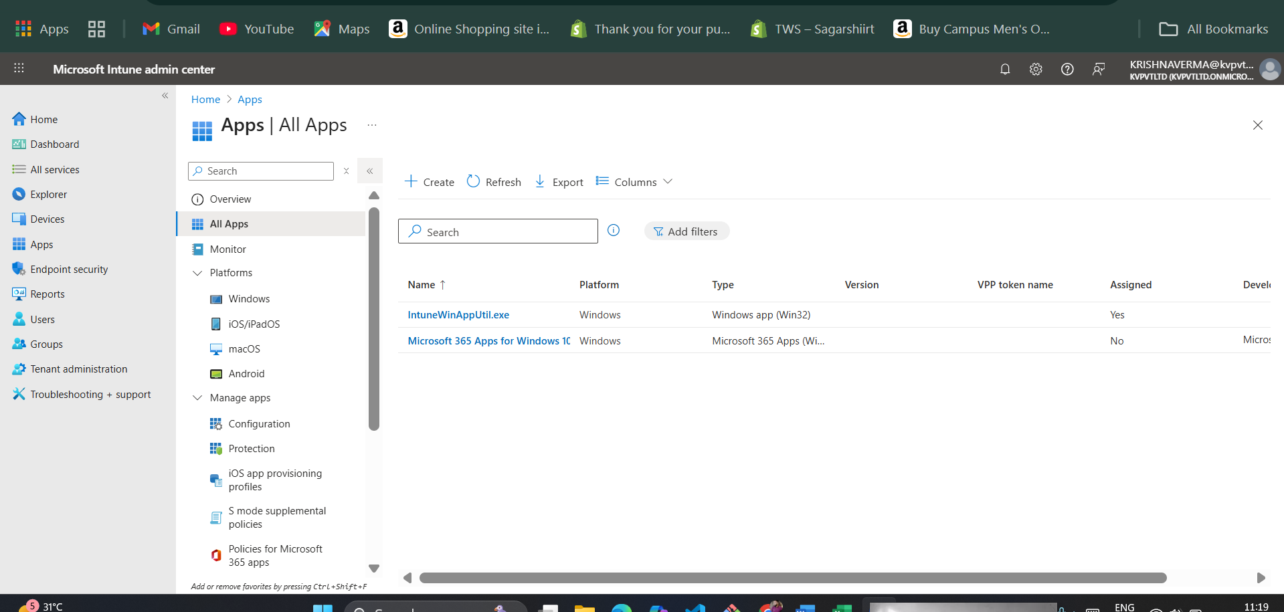
Getting Started
To use Intune, we need an Intune admin and tenant account. Sign up if you don't have one yet.
Creating a user for use with Microsoft Intune is done in the Microsoft Entra admin center, as Intune uses Microsoft Entra ID (formerly Azure Active Directory) for all user, group, and device identity management.
You cannot directly "create a user" within the Intune admin center itself. Instead, you create the user in Microsoft Entra ID and then assign them a license that includes Intune.
Here is a general guide on how to create a new user:
Step-by-Step Guide
- Sign in to the Microsoft Entra admin center: Go to https://entra.microsoft.com. You must have a role with sufficient permissions, such as User Administrator or Global Administrator.
- Navigate to the Users section: In the left-hand navigation pane, select Identity > Users > All users.
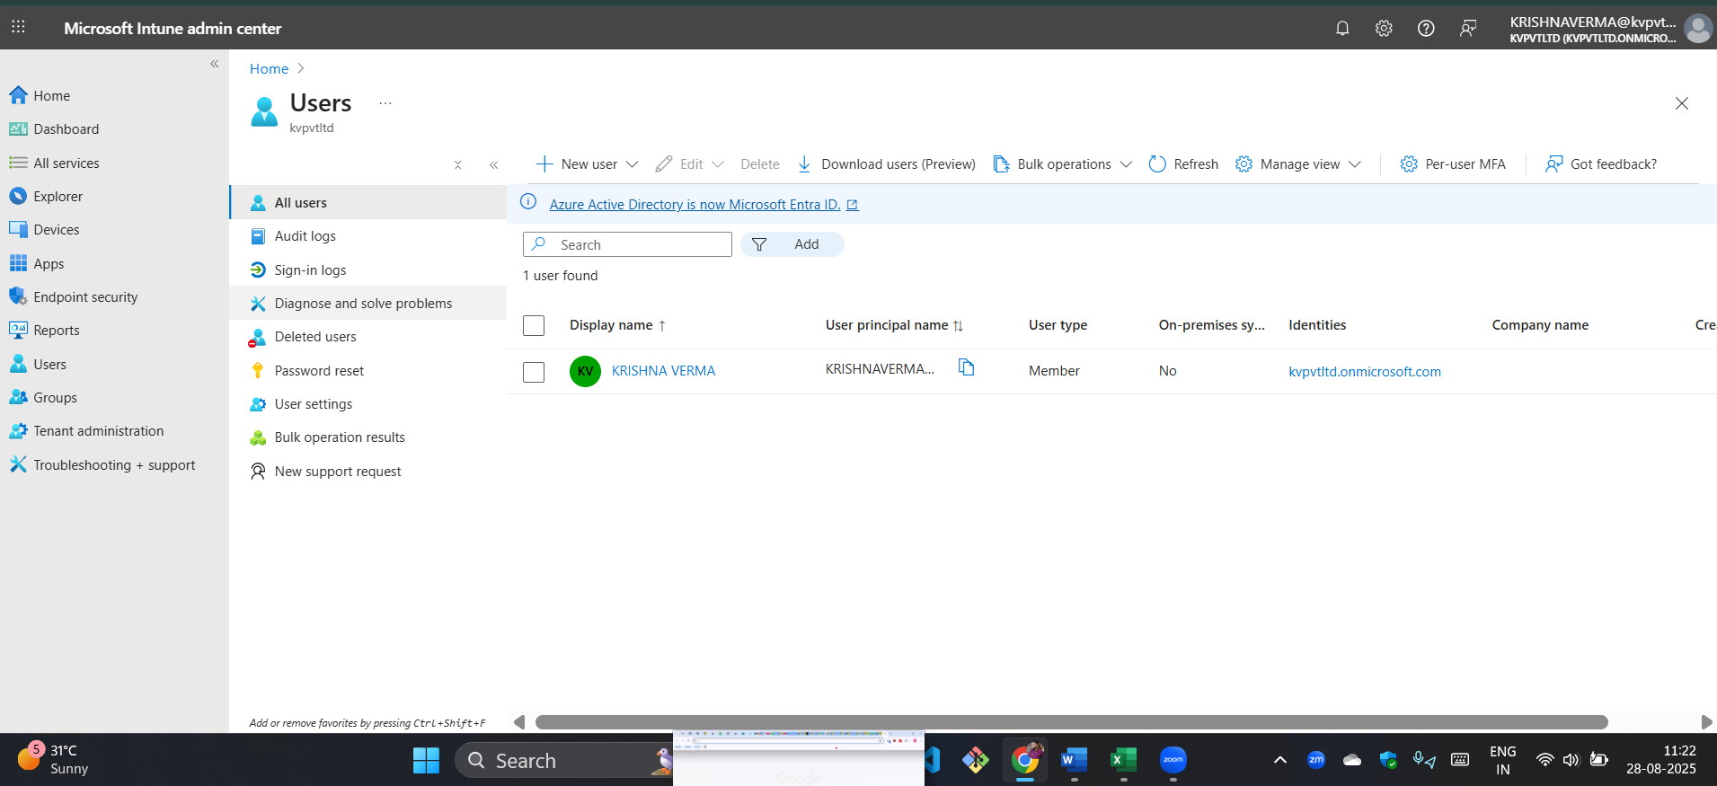
- Create a new user: On the "All users" page, select New user > Create new user.
- Fill in the basic user details: You will need to provide the following information:
  - User principal name: This is the user's unique sign-in name (e.g., user@yourdomain.com).
  - Display name: The user's full name (e.g., Jane Doe).
  - Password: You can have the system auto-generate a strong password or create one yourself. It's a best practice to require the user to change their password on the first sign-in.
  - First name and Last name: These are optional but recommended.
  - User type: Choose Member for internal employees or Guest for external collaborators.
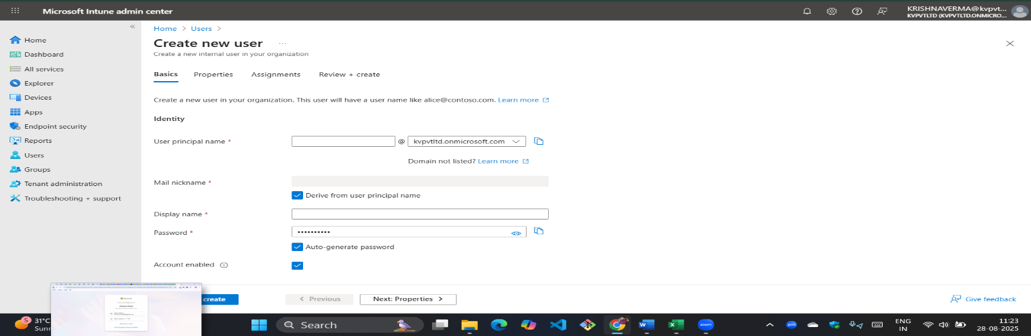
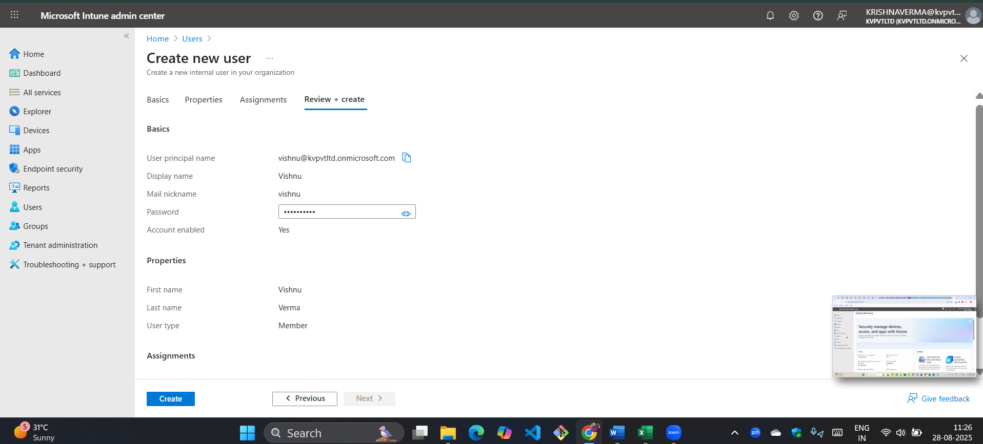
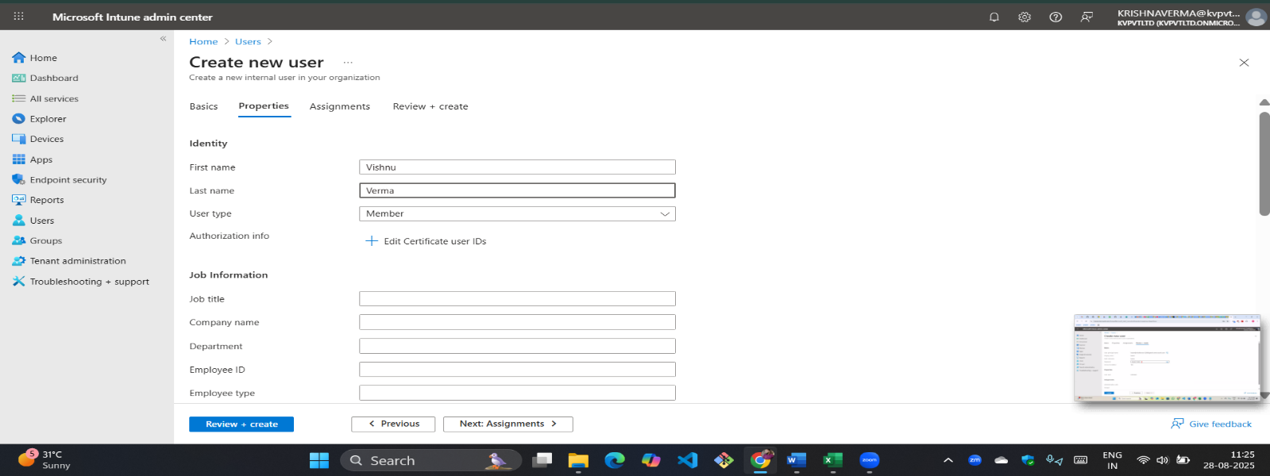
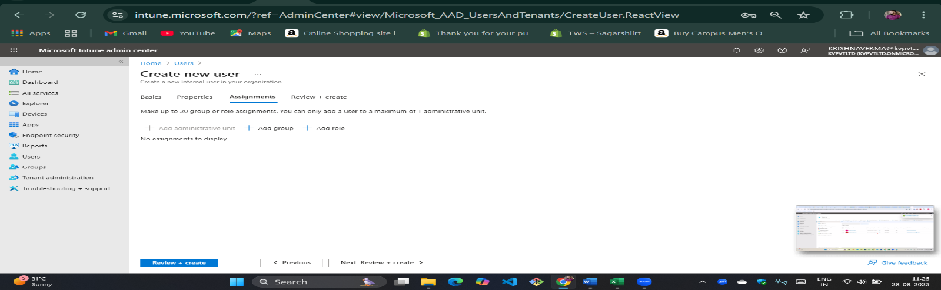
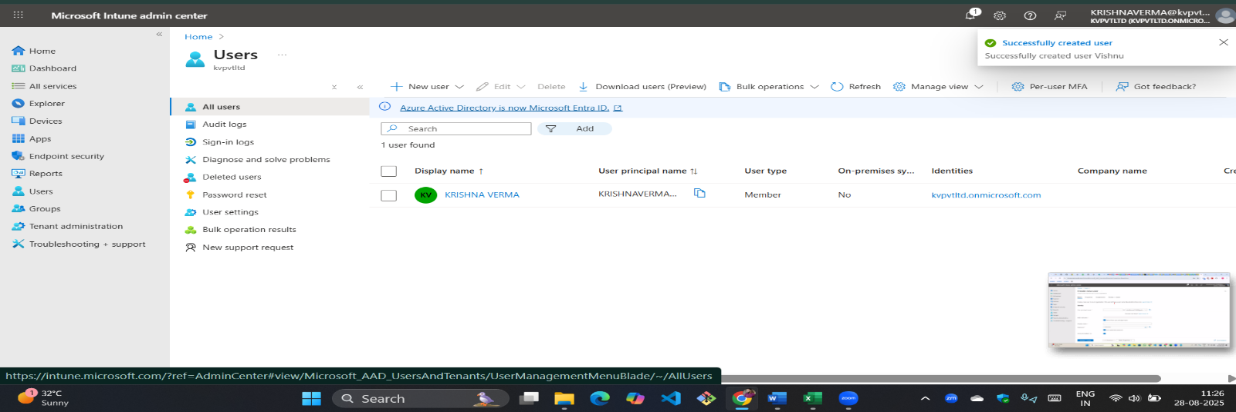

- Assign roles (Optional but important): You can assign administrative roles to the user at this stage. For a standard user, no roles are needed. For IT staff who will manage Intune, you should assign them a role like Intune Administrator or a custom Intune role with the principle of least privilege.
- Assign groups (Optional but recommended): Add the user to relevant groups. Groups are a critical part of Intune management as they are used to deploy apps, policies, and configurations to specific sets of users.
- Review and create: Review all the details and click Create. The new user account is now active in your organization's Microsoft Entra ID.
Final and Critical Step: Assigning a License
A user account is useless for Intune until it has the appropriate license. You can assign a license in two ways:
- During user creation: You can assign licenses during the user creation process.
- After user creation: Go to Users > All users, select the user you just created, then click on Licenses > Assignments. From there, you can select the license that includes Intune (e.g., Microsoft 365 E3, E5, F3, or Intune Standalone).
Once a user has an account and a license, they can enroll their devices in Intune and access corporate resources based on the policies you have configured.
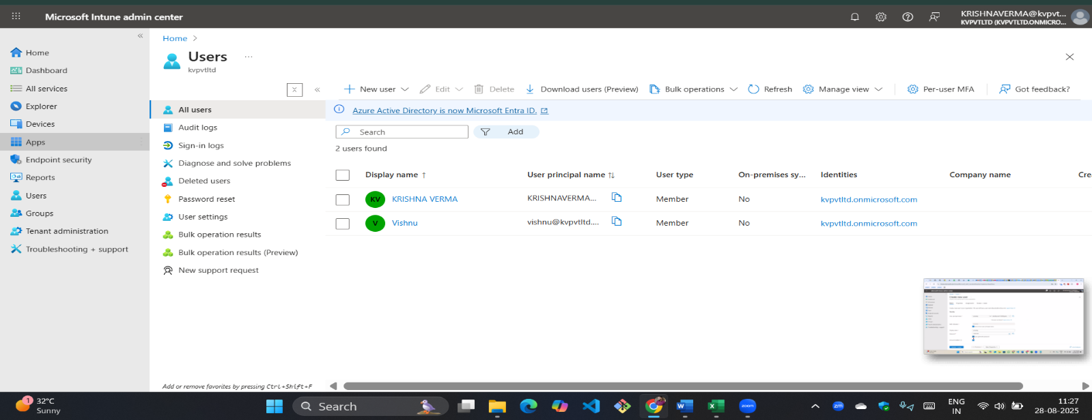
How to Create a Group
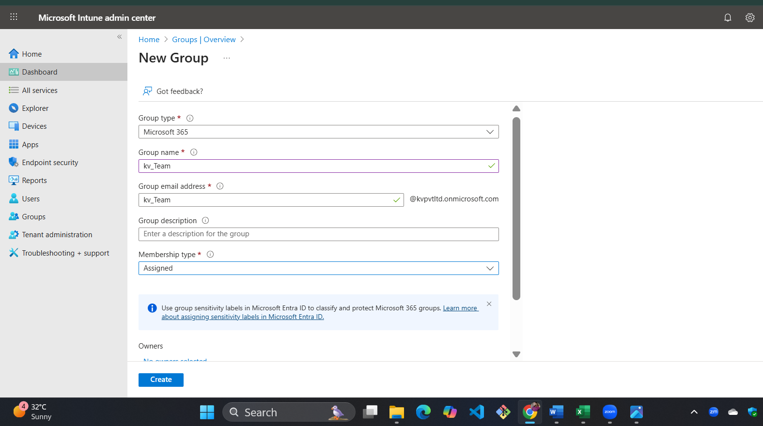
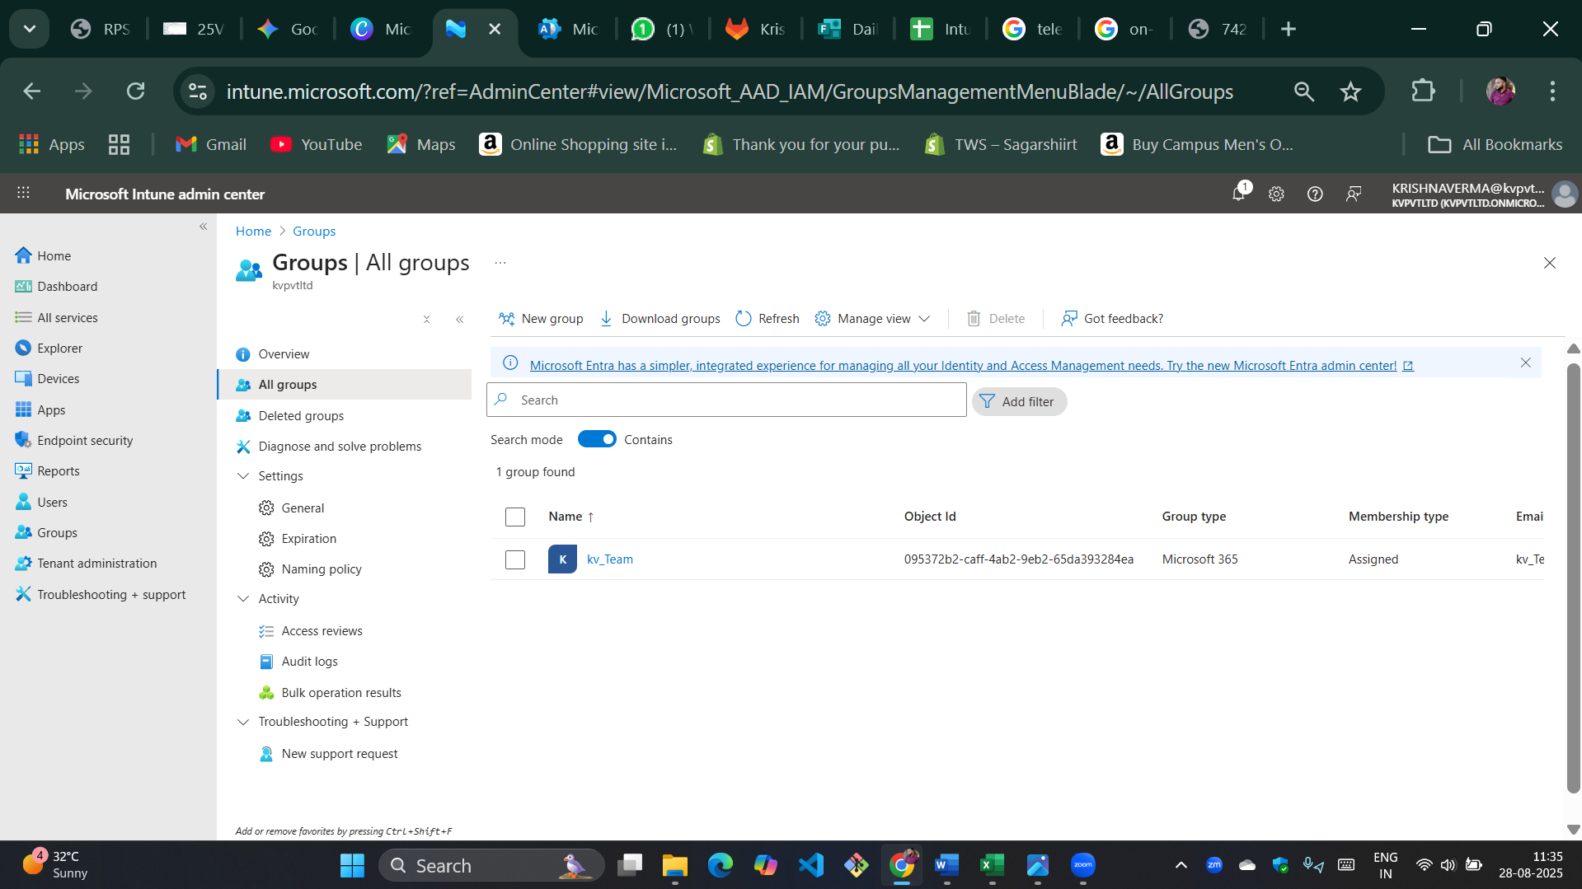

Setting Up Windows Automatic Enrollment
In this example, we will utilize MDM enrollment to ensure that both corporate and bring-your-own devices can be automatically enrolled. To start, you will need to register for a free Azure Active Directory Premium subscription.

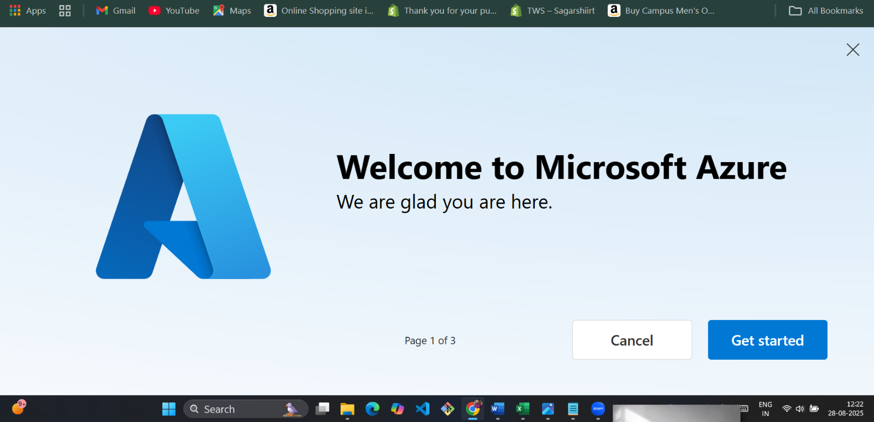
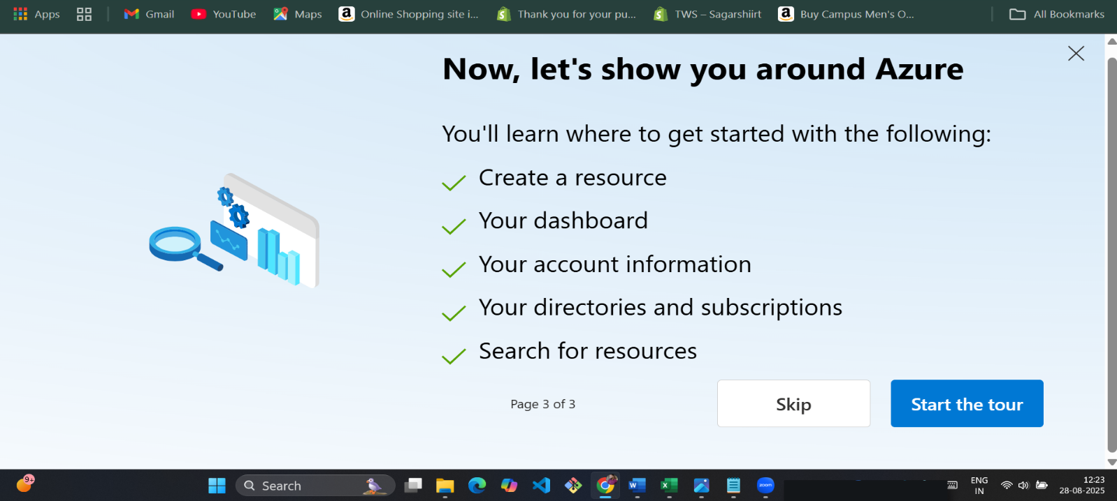
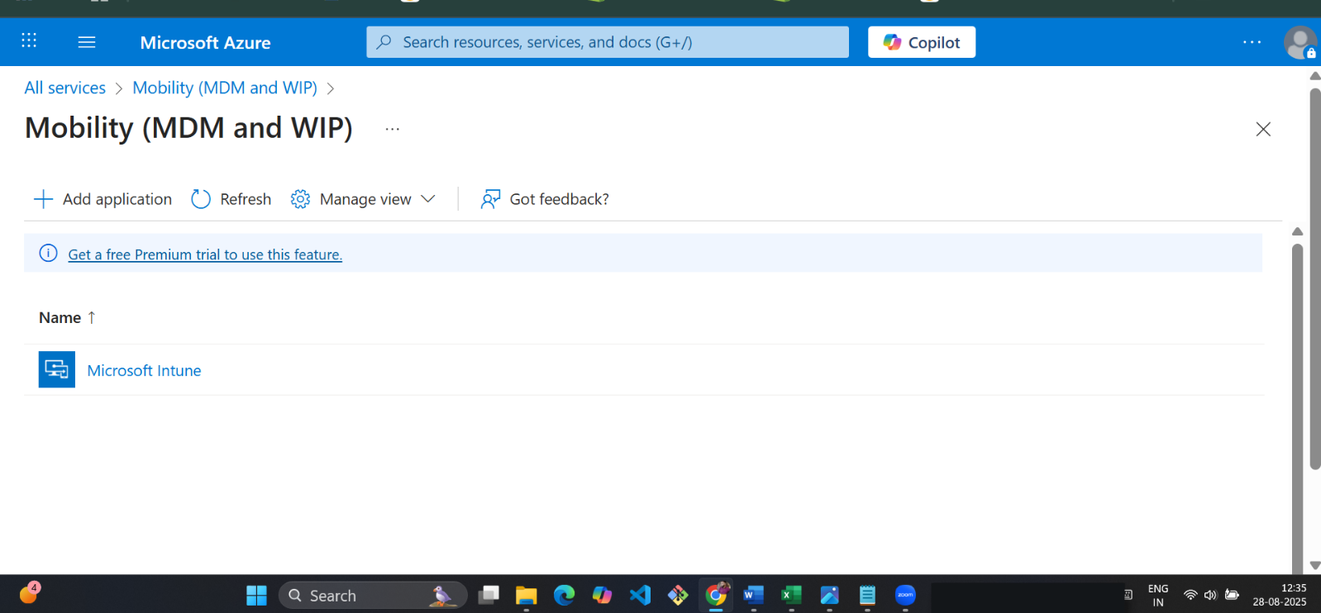
- For MDM user scope, select “Some” to enable MDM auto-enrollment for managing enterprise data on employees' Windows devices. This applies to both AAD-joined and personal devices.
- Go to “Select groups,” choose “Contoso Testers,” and click “Select” to assign the group.
- For MAM user scope, select “Some” to manage data on workforce devices.
- Again, go to “Select groups,” choose “Contoso Testers,” and click “Select” to assign the group.
- Keep the default values for the rest of the configuration.
- Click “Save.”
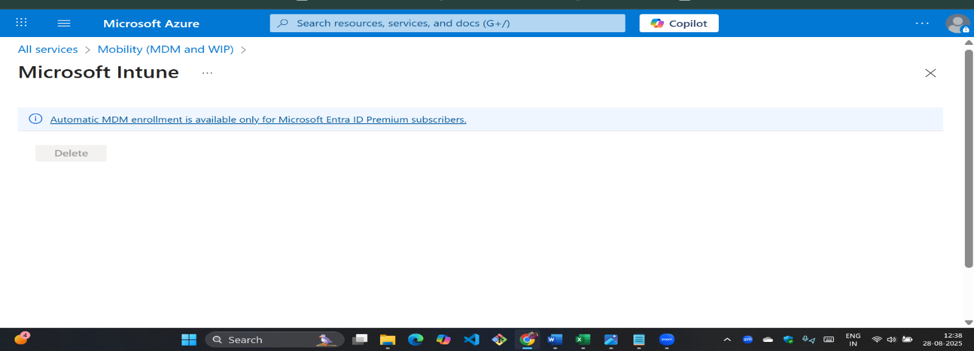
Check Your Windows 10 Desktop Version
Before enrolling your Windows 10 Desktop, verify your installed version.
- Right-click the Windows Start icon and choose Settings to open Windows Settings.
﻿
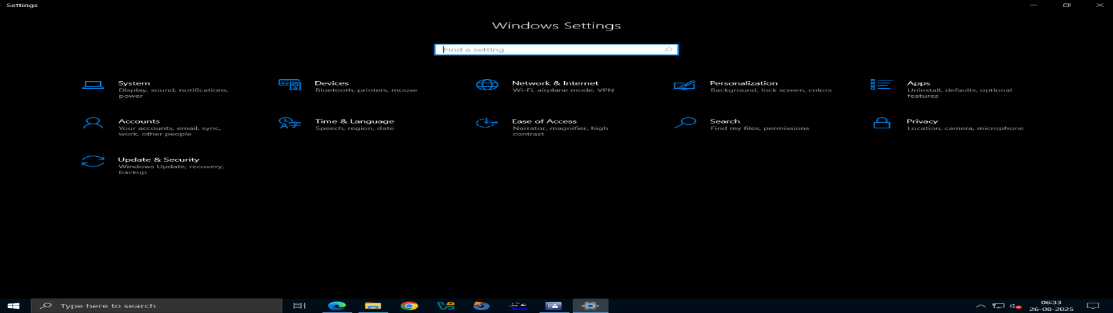
﻿
2.Select System > About.
﻿
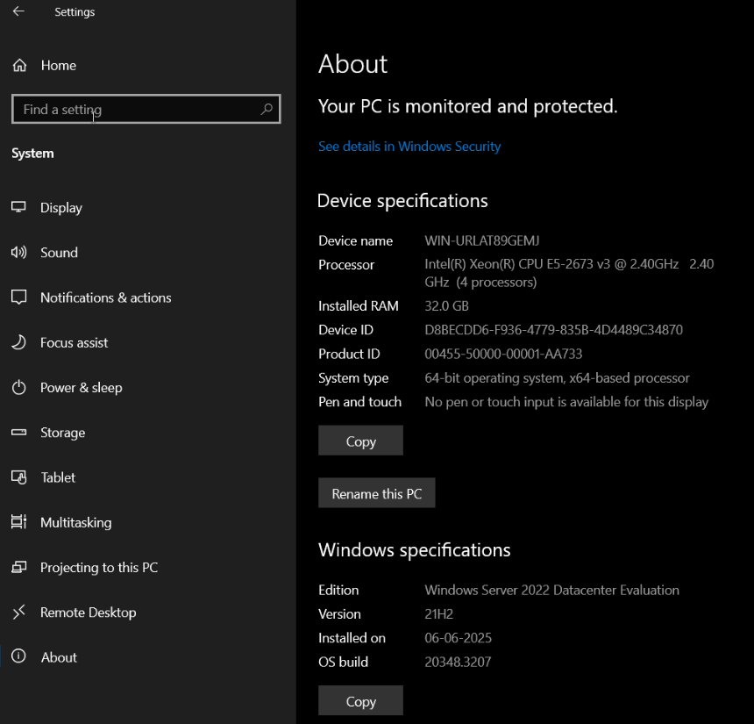
﻿
- Type "About your PC" in the search bar and select it. In the Settings window, find the Windows specifications list for your PC. Look for the Version and check that your Windows 10 Version is 1607 or higher.
- Edition: Windows Server 2022 Datacenter Evaluation
- Version: 21H2
- Installed on: 06-06-2025
- OS build: 20348.3207
✅ Since my Windows version is 21H2, it is higher than 1607.
So, my system meets the requirement.
Enroll Windows 10 Desktop
﻿
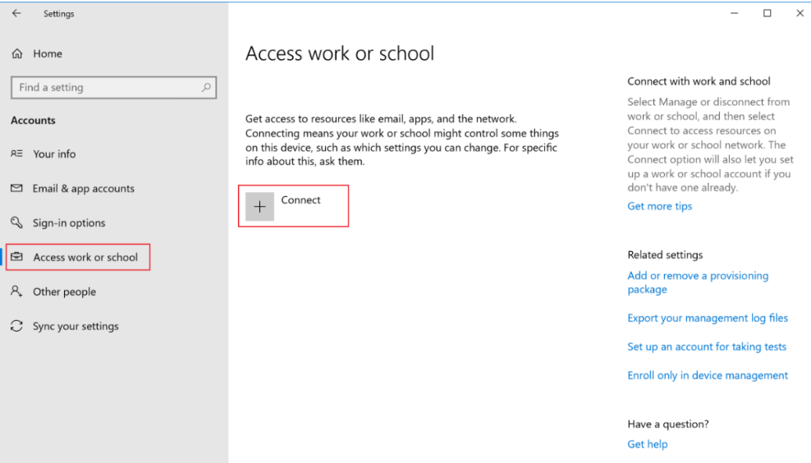
﻿
- Go to "Access work or school" and click "Connect".
- Sign in to Intune with your work or school account and click "Next." If you created a user and assigned a license earlier, sign in with that account. Note: If you're setting up an ".onmicrosoft.com" account, the address will include ".onmicrosoft.com."
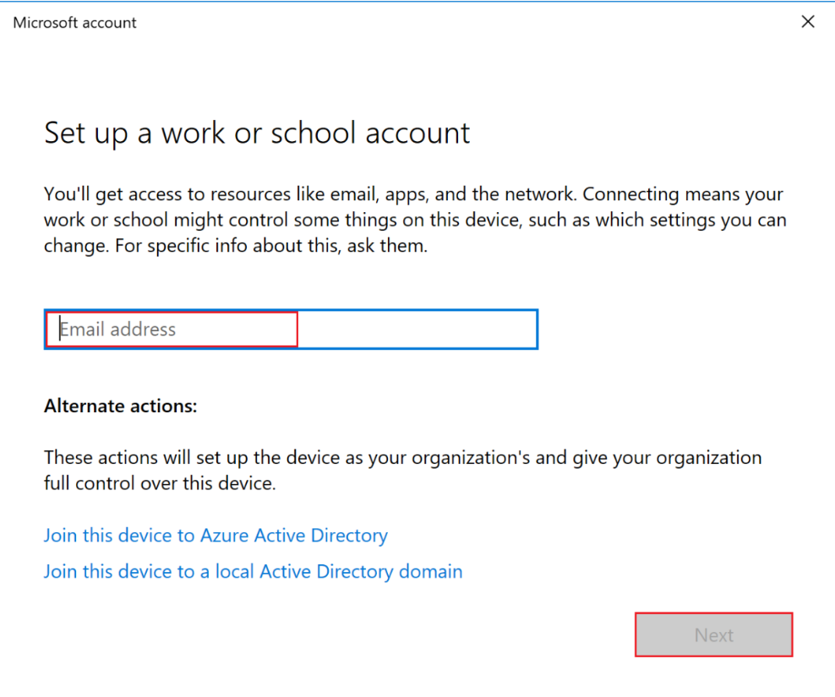
﻿
- You will see a message that your company or school is registering your device.
- When the "You’re all set!" screen appears, click Done.
- Your account will now be added to the Access work or school settings on your Windows Desktop.
Sign in to Intune as a Global Administrator or an Intune Service Administrator. Go to Devices and select All devices to see the devices enrolled in Intune. Check if you have an extra device enrolled in Intune.
﻿
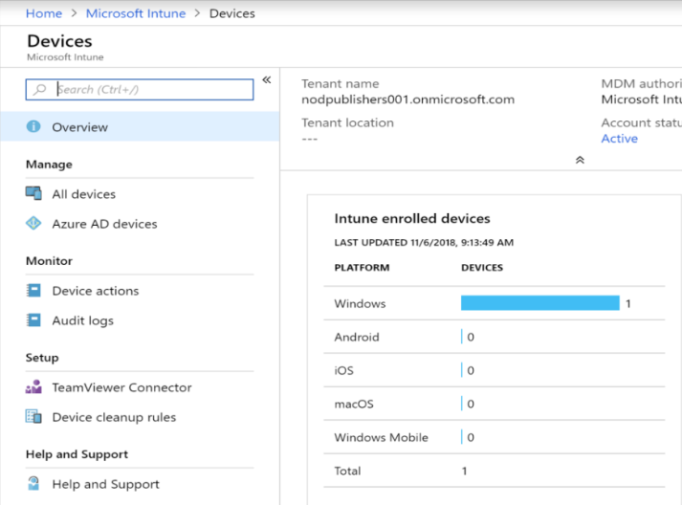
﻿
Create a device compliance policy using Intune to ensure your Android users set a password of a specific length for device access.
- In Intune, go to Device compliance > Policies > Create Policy.
- Name it “Android compliance” and provide a description.
- Choose Android for the Platform.
- Go to Settings > System Security to access Android System Security.
- Enable the option to require a password to unlock mobile devices.
- Set the password type to at least numeric.
- Set the minimum password length to 6.
﻿
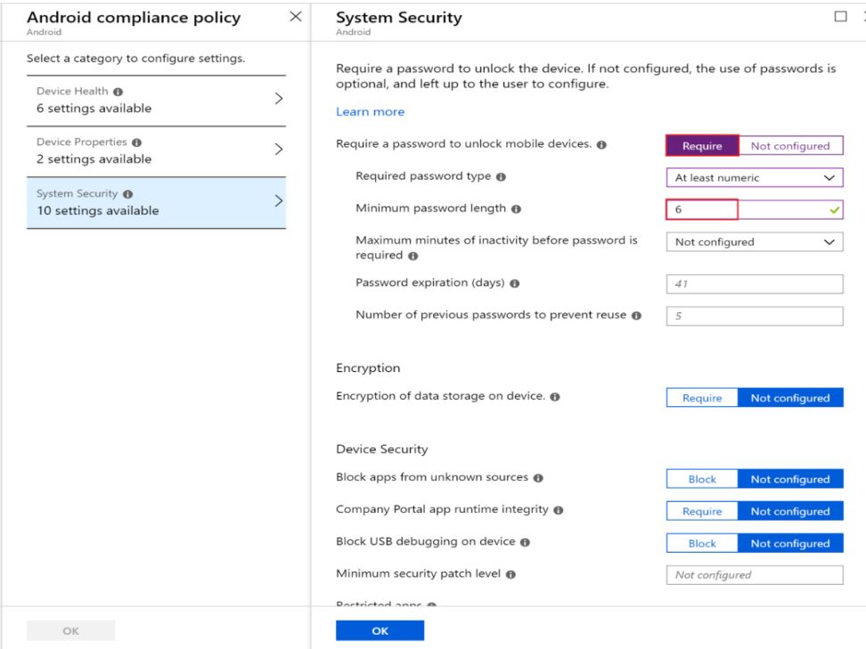
﻿
- When done, click OK > OK > Create to create the policy.
Add the client app to Intune
An app can be included so that Intune can manage aspects of the app.
- To add an app to Intune, follow these steps:
- In Intune, go to Client apps > Apps > Add.
- Choose Windows 10 from the App type dropdown in the Office 365 Suite section.
- Click Configure App Suite to choose the Office apps for the Intune user.
- Click OK to confirm the default selected apps.
- Select App Suite Information.
- Name it Microsoft Office 365 app suite.
- Describe it as The Microsoft Office 365 app suite.
- Click Yes to feature this app in the Company Portal, then click OK.
﻿
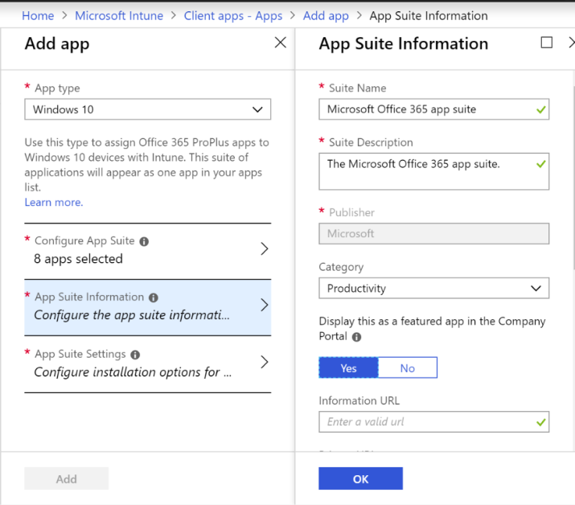
﻿
Select "App Suite Settings." In the "Update Channel" dropdown, choose "Monthly." Click "OK" then "Add."
Assign the app to a group:
- In Intune, select "Client apps" > "Apps."
- Choose the app to assign.
- Click "Assignments" > "Add group."
- In "Assignment type," select "Available for enrolled devices."
- Click "Included Groups" > "Select groups to include" > "Testers."
- Click "Select" > "OK" > "OK" > "Save."
Now, the app is assigned to the Testers group.
Install the app on the enrolled device:
- Log in to your enrolled Windows 10 device. Ensure it's enrolled with Intune and you're using an appropriate account.
- Open Microsoft Store from the Start menu, find, and install the Company Portal app.
- Launch the Company Portal app.
- Click the app you added with Intune.
- Click "Install."
Create an app protection policy:
- In Intune, select "Client apps" > "App protection policies" > "Create Policy."
- Enter details:
  - Name: "Windows 10 content protection"
  - Description: Users can't cut, copy, or paste content between the app and non-managed apps.
  - Platform: "Windows 10"
  - Enrollment state: "With enrollment"
- Select "Protected apps" and choose apps for the policy.
- Click "Add apps," select "Word Mobile."
- Click "OK" > "OK."
- Configure settings by selecting "Required settings."
- Click "Allow Overrides" for Windows Information Protection mode.
- Click "OK" > "Create."
The policy is now visible in Intune.
Assign the app protection policy:
- In Intune, go to "Client apps" > "App protection policies."
- Select the policy, e.g., "Windows 10 content protection."
- Click "Assignments."
- In the "Include" tab, choose "Select groups to include."
- Select "Contoso Testers."
- Click "Select" > "Save."
Create a custom role:
Set permissions for security operations, allowing the operator to review device configurations and policies with specific Read permissions.
﻿
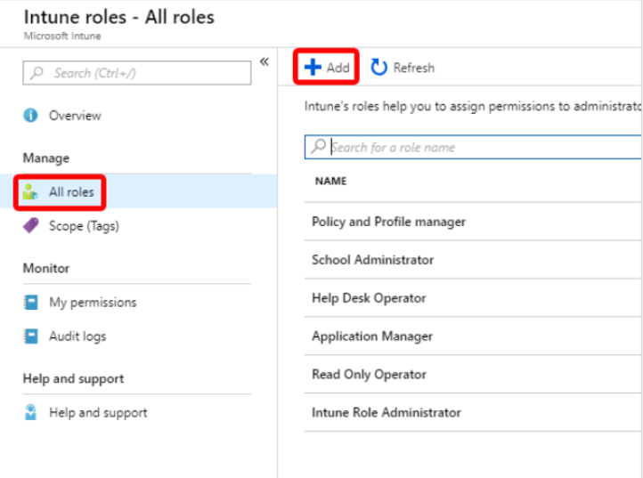
﻿
- Go to Add custom role, and in the Name box, type “Security operations.”
- In the Description box, input: “This role allows a security operator to monitor device configuration and compliance information.”
- Select Configure, then Corporate device identifiers, choose Yes next to Read, and click OK.
﻿
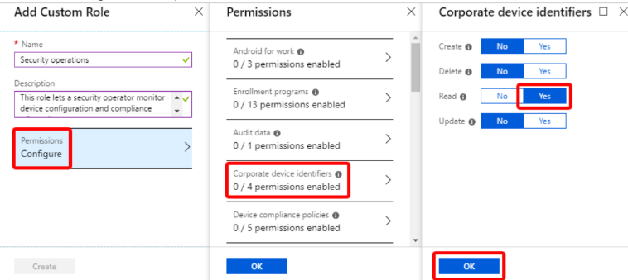
﻿
- Go to Device compliance policies and select "Yes" next to Read, then click "OK."
- Go to Device configurations and select "Yes" next to Read, then click "OK."
- Go to Organization and select "Yes" next to Read, then click "OK."
- Click "OK," then "Create."
Assign the role to a group:
- Before the security operator can use the new permissions, assign the role to a group with the security user.
- In Intune, go to Roles, then All roles, and select Security operations.
- Under Intune roles, select Assignments, then Assign.
- In the Assignment name box, type "Sec ops."
- Select Member (Groups), then "Add."
- Select the Contoso Testers group.
- Click "Select," then "OK."
- Go to Scope (Groups), select groups to include, and choose Contoso Testers.
- Click "Select," then "OK," and "OK" again.

